### **1. Test Data Sets**

#### **Basic Functionality**

* **Add Task**: Test adding tasks with different lengths and characters.
  + Task 1: “Buy groceries”
  + Task 2: “Complete Python project”
  + Task 3: “Call mom”
  + Task 4: “Read a book”
  + Task 5: “Plan weekend trip”

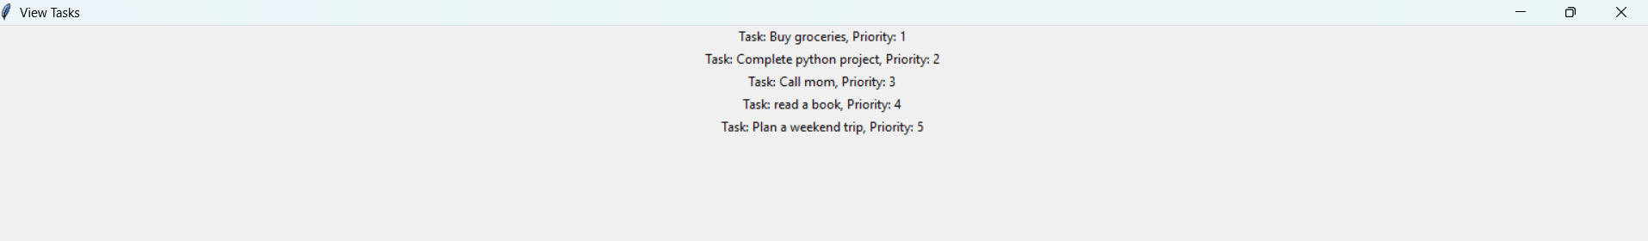

#### 

* **Empty Task**: Test adding an empty task.
  + 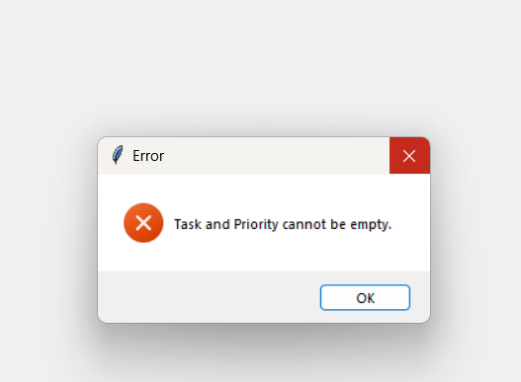
* **Special Characters**: Test tasks with special characters.
  + 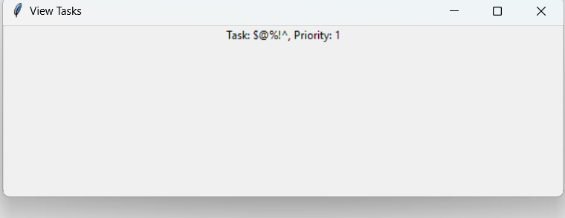
* **Long Task**: Test adding a very long task.
  + Task: “This is a very long task description to test how the application handles long strings and whether it can display them properly without any issues.”
  + 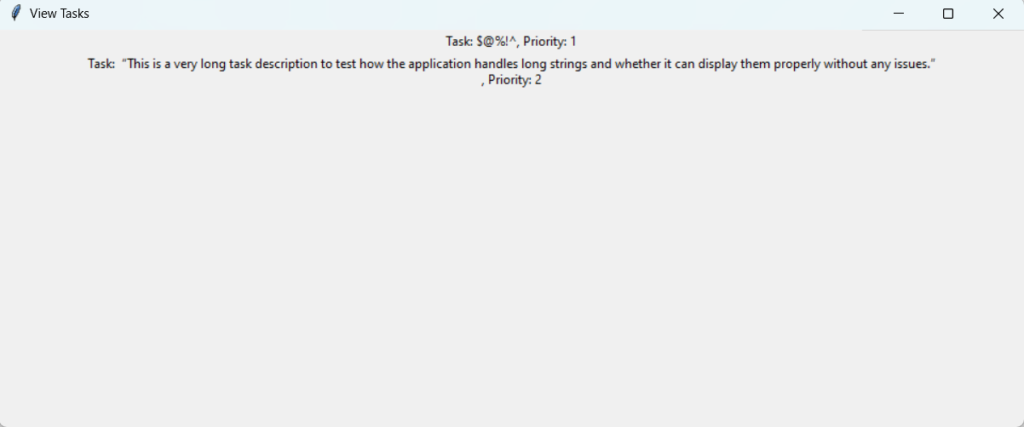

### **2. Test Results and Fixes**

#### **Add Task**

* **Result**: All tasks were added successfully.
* **Fixes**: None required.

#### **Delete Task**

* **Result**: Tasks were not deleted successfully.
* **Fixes**: Add delete button

#### **Empty Task**

* **Result**: Application should prevent adding empty tasks.
* **Fixes**: Added validation to check for empty input before adding a task.

#### **Special Characters**

* **Result**: Task with special characters was added successfully.
* **Fixes**: None required.

#### **Long Task**

* **Result**: Long task was added successfully, but the display was not optimal.
* **Fixes**: Adjusted the GUI layout to handle long strings better.